Housing Affordability in Maricopa County, Arizona (2020–2024)
Darius Johnson
CIS480
Introduction
Housing affordability has become a major issue in many parts of the United States, especially in fast-growing areas like Maricopa County, Arizona. As home prices continue to rise, many households are finding it harder to afford housing. This creates financial pressure and limits access to stable living conditions.
The purpose of this project is to analyze the relationship between median household income and median home value across ZIP codes in Maricopa County. By understanding this relationship, we can better evaluate housing affordability and identify areas where housing may be less affordable.
The main research question for this project is:
Does higher household income lead to higher home values, and how does this relationship impact housing affordability across ZIP codes?
This project uses data from the American Community Survey (ACS) from 2020–2024. Power BI is used to create interactive dashboards, and Python is used for data cleaning and preparation.
Data Collection and Preparation
The dataset used in this project was obtained from PolicyMap using ACS 5-year estimates (2020–2024). The key fields include:
- Estimated median income of a household (2020–2024)
- Estimated median value of an owner-occupied home (2020–2024)
- ZIP Code Tabulation Area
Before analysis, the data was cleaned using Python. This included:
- Removing missing or incomplete values
- Converting income and home value columns to numeric format
- Ensuring ZIP codes were treated as text (categorical values)
After cleaning, the dataset was imported into Power BI.
Calculated Measure
A key metric used in this project is the Price-to-Income Ratio, calculated as:
Price-to-Income Ratio = AVERAGE(Home Value) ÷ AVERAGE(Income)
This measure helps evaluate housing affordability. A higher ratio means housing is less affordable relative to income.
Data Analysis and Visualizations
1. Scatter Plot Analysis
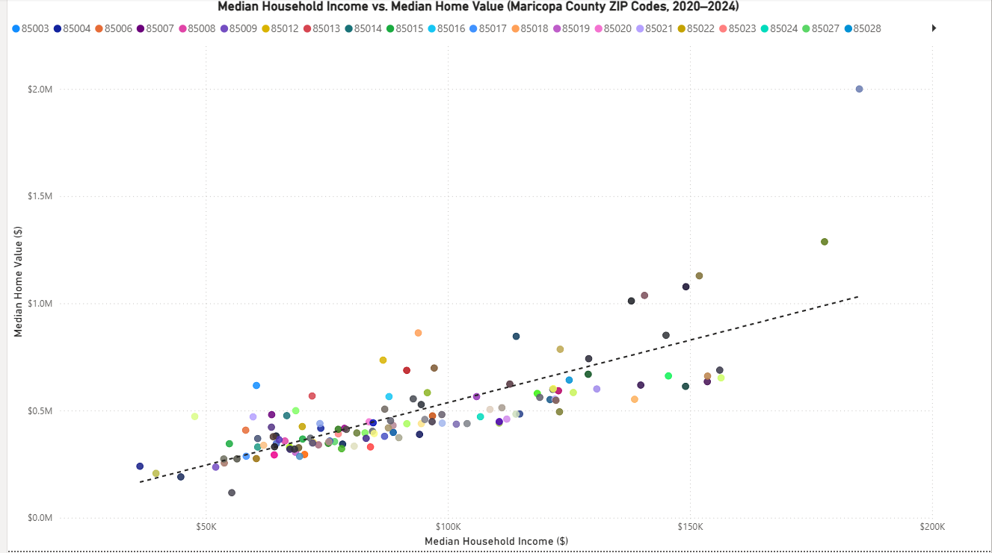
(Income vs. Home Value scatter plot)
As shown in Figure 1, this visualization shows the relationship between household income and home value.
- H₀: There is no relationship between income and home value
- H₁: Higher income is associated with higher home values
- Test Type: One-tailed (directional expectation)
The scatter plot shows a clear upward trend, meaning that as income increases, home value also increases. Most ZIP codes cluster between $50K–$100K income and $300K–$600K home values.
There are also outliers, especially in higher-income ZIP codes, where home values are much higher than average. Based on this pattern, the null hypothesis is rejected.

2. Bar Chart Analysis
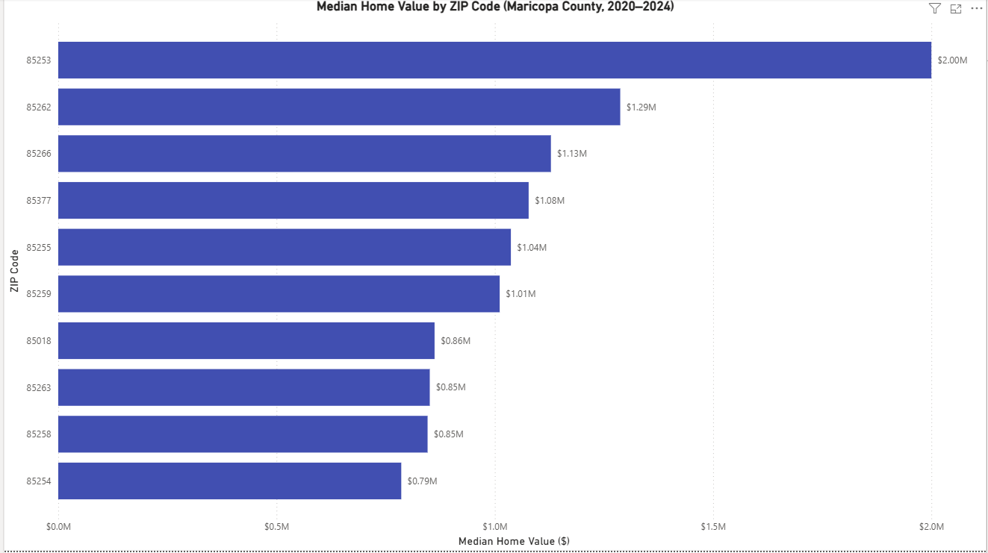
(Median Home Value by ZIP Code)
As shown in Figure 2, this chart compares home values across ZIP codes.
- H₀: Home values do not differ across ZIP codes
- H₁: Home values differ across ZIP codes
- Test Type: Two-tailed (differences in either direction)
The results show large differences in home values. Some ZIP codes have home values above $1.5M, while others are much lower. This confirms that location plays a major role in housing prices.
The null hypothesis is rejected.
3. Map Visualization
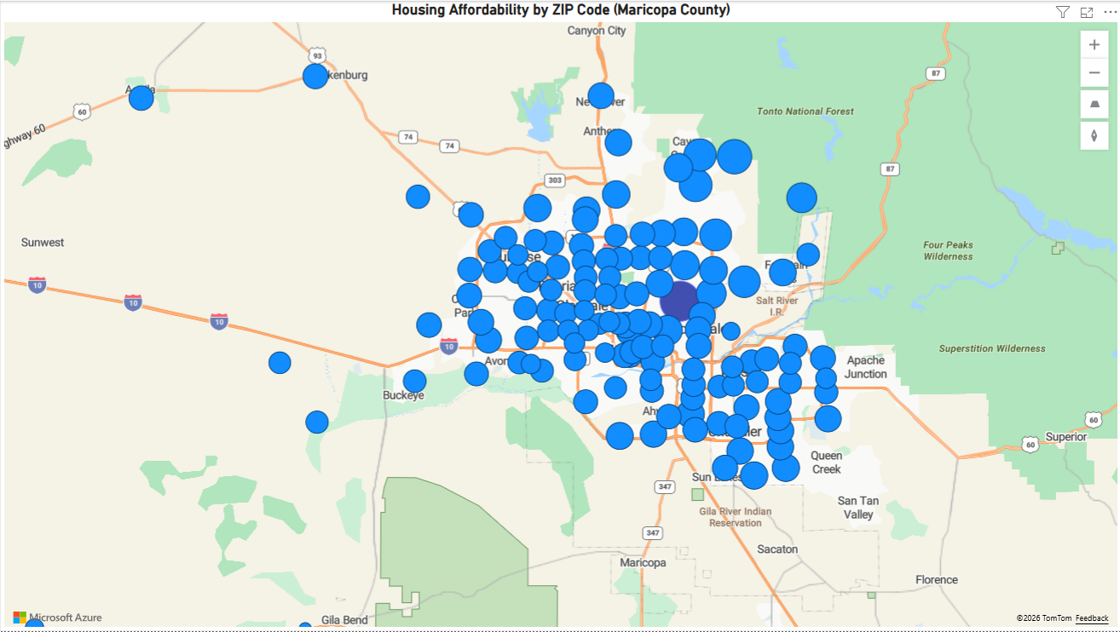
(Housing Affordability Map)
As shown in Figure 3, this map shows geographic patterns in housing affordability.
- H₀: Income and home values are evenly distributed geographically
- H₁: There are geographic differences in affordability
- Test Type: Two-tailed
The map shows clustering of high home values in certain areas, especially North Scottsdale. Larger bubbles represent higher home values.
This confirms that affordability varies by location, so the null hypothesis is rejected.
4. KPI / Summary Metrics
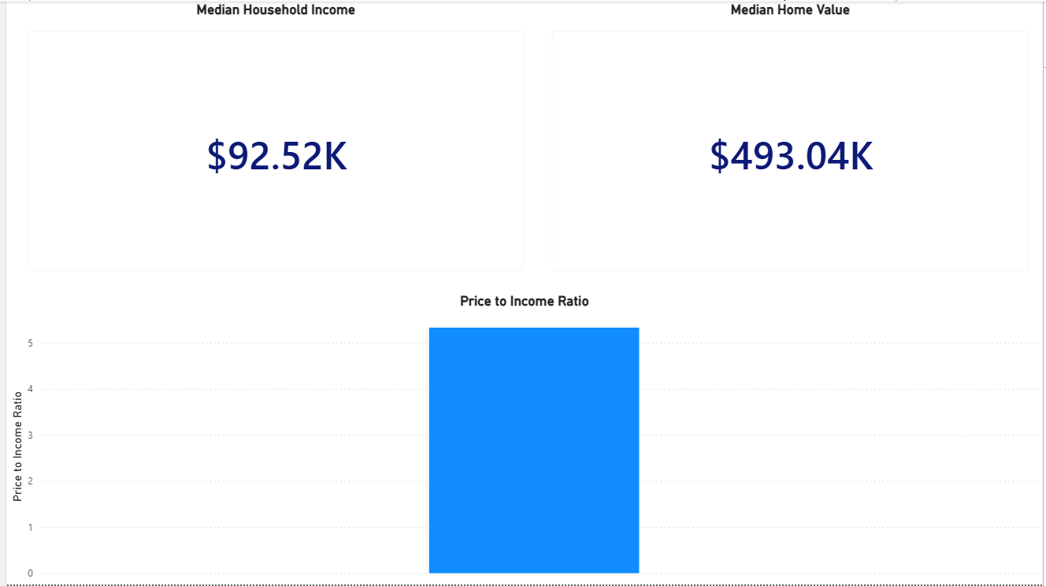
- Average Household Income: ~$92.52K
- Average Home Value: ~$493.04K
- Price-to-Income Ratio: ~5.3
- H₀: Housing is affordable (low ratio)
- H₁: Housing is less affordable (higher ratio)
- Test Type: One-tailed
The ratio of 5.3 suggests moderate to low affordability, meaning home prices are relatively high compared to income. The null hypothesis is rejected.
Dashboard Design and Insights
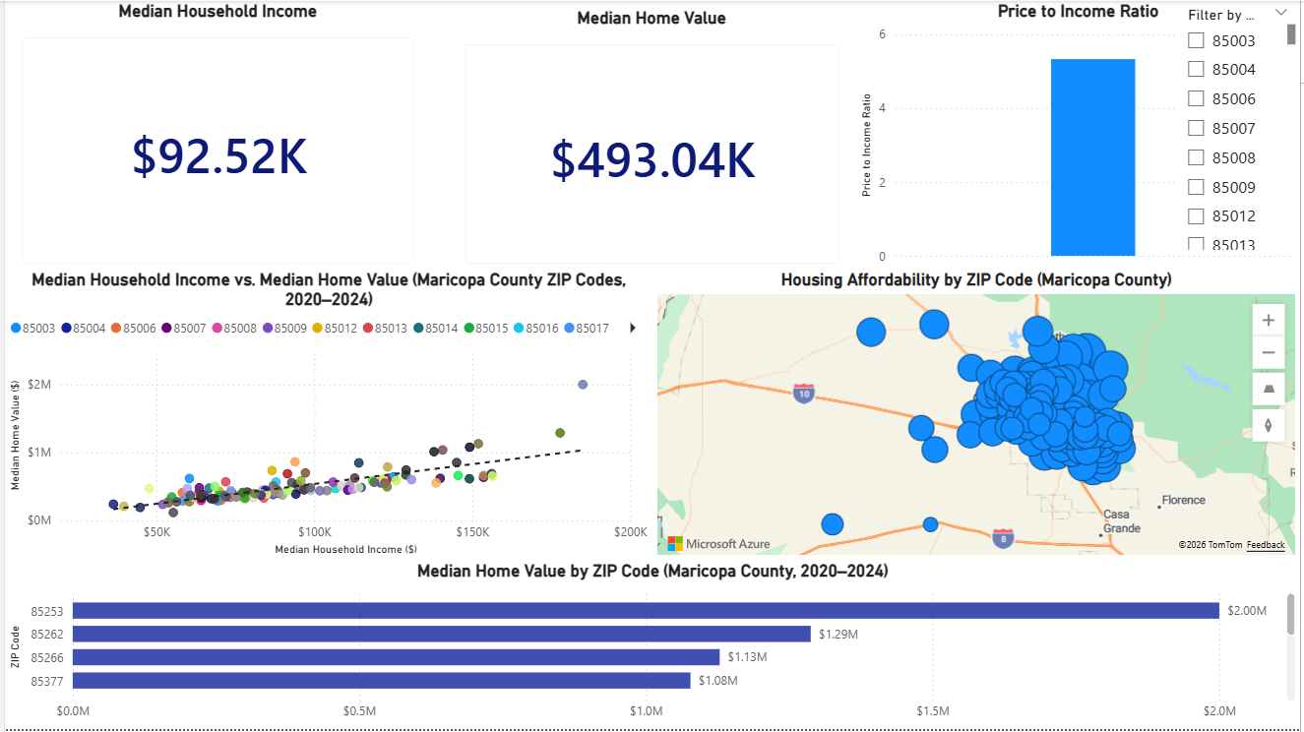
As shown in Figure 5, the Power BI dashboard combines all visuals into one page for easy understanding. It includes:
- KPI summary cards
- Scatter plot
- Map visualization
- Bar chart
Interactivity Features
- Slicer allows filtering by ZIP code
- Cross-filtering updates all visuals when one is selected
- Tooltips show:
  - ZIP code
  - Income
  - Home value
  - Price-to-income ratio
Key Insights
- Strong positive relationship between income and home value
- Most ZIP codes fall into a mid-range cluster
- High-income areas show much higher home values
- Certain ZIP codes (like Scottsdale areas) are less affordable
The dashboard is designed to be simple, clear, and useful for both technical and non-technical users.
Summary of Hypotheses and Results
All hypotheses tested in this project were rejected based on the data.
- Income and home value have a strong positive relationship
- Home values differ significantly by ZIP code
- Housing affordability varies by geographic location
- The price-to-income ratio shows moderate affordability challenges
These results are supported by all visualizations, including the scatter plot, bar chart, map, and KPI metrics.
Project Reflection
This project helped build important skills in data analysis and visualization. I learned how to clean data using Python, create measures in Power BI, and design dashboards that communicate insights clearly.
One challenge was working with a limited dataset. Only income and home value were available, which limited deeper analysis. Adding variables like unemployment or education would improve the model.
Another challenge was correctly applying statistical reasoning, especially defining hypotheses and choosing the correct test type. After feedback, I improved how I explained one-tailed and two-tailed tests.
This project also improved my ability to connect data to real-world problems and explain results clearly.
Real-World Implications
Housing affordability is a major issue that affects many parts of society, including income inequality, public policy, transportation, and economic development. This project helps identify areas where housing costs are increasing faster than income, which makes it harder for people to afford homes. By comparing income and home value across ZIP codes, this analysis shows where affordability problems are most serious.
One major impact is related to income inequality. The results show that while higher-income areas can support higher home values, lower-income households struggle to keep up with rising housing costs. This can lead to displacement, where people are forced to move out of their communities to find more affordable housing. When this happens, individuals may lose access to nearby jobs, schools, and support systems. Over time, this increases the gap between higher-income and lower-income groups.
This issue is also connected to transportation. When housing becomes too expensive in central areas, people often move farther away to find more affordable homes. This leads to longer commute times, higher transportation costs, and more traffic. In a large and growing area like Maricopa County, this can put pressure on infrastructure and reduce overall quality of life.
The findings are also important for public policy and urban planning. Local governments can use this type of analysis to identify ZIP codes with the highest price-to-income ratios. These are areas where housing is least affordable. Policymakers can respond by creating affordable housing programs, adjusting zoning laws, or encouraging new housing development. For example, increasing housing supply in high-demand areas could help reduce prices over time.
This project also has implications for economic development. Businesses rely on workers being able to live near their jobs. If housing becomes too expensive, companies may struggle to attract and retain employees. Developers and investors can also use this data to identify areas with high demand or future growth opportunities.
Housing affordability also affects long-term financial stability. Homeownership is one of the main ways people build wealth. If home prices continue to rise faster than income, it becomes harder for people, especially first-time buyers, to enter the housing market. This can limit financial growth and increase economic inequality over time.
Another important impact is on younger generations. High housing costs can delay major life decisions, such as buying a home, getting married, or starting a family. Many younger individuals may choose to rent longer or move to different cities where housing is more affordable. This can shift population patterns and affect local economies.
This analysis can also support community organizations and housing programs. Non-profit organizations can use this data to focus their efforts on areas with the greatest affordability challenges. This helps ensure that resources are used effectively and reach the people who need them most.
However, there are some limitations to this analysis. The data uses median values, which means it does not show all variations within a ZIP code. Some neighborhoods within the same ZIP code may be more or less affordable than others. The dataset also only covers the years 2020–2024, which may not fully reflect long-term trends.
Another limitation is that only two main variables were used: income and home value. Other factors, such as interest rates, employment, housing supply, and population growth, also affect affordability. Including these variables in future analysis would provide a more complete picture.
Overall, this project shows how data analysis can help explain real-world problems like housing affordability. It highlights important patterns and differences across locations and provides useful insights for policymakers, businesses, and communities. With additional data and further analysis, this type of work can help guide better decisions and improve housing outcomes in the future.
References
U.S. Census Bureau. (2023). American Community Survey 5-Year Estimates.
https://www.census.gov
Powell, B. (2018). Mastering Microsoft Power BI. Packt Publishing.
Microsoft. (2023). Power BI Documentation.
https://learn.microsoft.com/power-bi

